Unit - 1
Testing of 1-ɸ transformers
- Sumpner's Test Or Back-To-Back Test On Transformer

Sumpner's test or back to back test on transformer is another method for determining transformer efficiency, voltage regulation and heating under loaded conditions. Short circuit and open circuit tests on transformer can give us parameters of equivalent circuit of transformer, but they cannot help us in finding the heating information. Unlike O.C. and S.C. tests, actual loading is simulated in Sumpner's test. Thus the Sumpner's test give more accurate results of regulation and efficiency than O.C. and S.C.tests.
Sumpner's test or back to back test can be employed only when two identical transformers are available. Both transformers are connected to supply such that one transformer is loaded on another. Primaries of the two identical transformers are connected in parallel across a supply. Secondaries are connected in series such that emf's of them are opposite to each other. Another low voltage supply is connected in series with Secondaries to get the readings, as shown in the circuit diagram shown below.

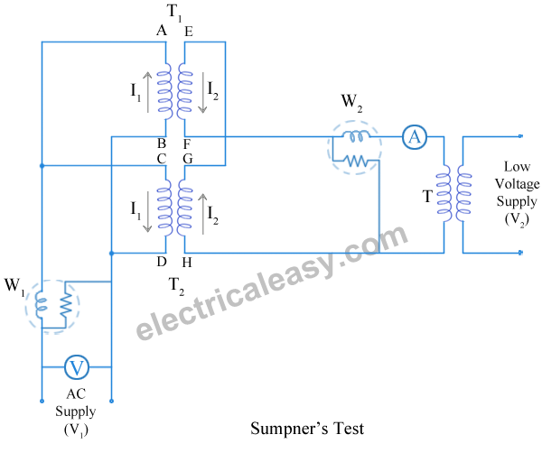

In above diagram, T₁ and T₂ are identical transformers. Secondaries of them are connected in voltage opposition, i.e. E_{EF} and E_{GH}. Both the emf's cancel each other, as transformers are identical. In this case, as per superposition theorem, no current flows through secondary. And thus the no load test is simulated. The current drawn from V₁ is 2I₀, where I₀ is equal to no load current of each transformer. Thus input power measured by wattmeter W₁ is equal to iron losses of both transformers.
i.e.ironloss per transformer Pi = W₁/2.
Now, a small voltage V₂ is injected into secondary with the help of a low voltage transformer. The voltage V₂ is adjusted so that, the rated current I₂ flows through the secondary. In this case, both primaries and secondaries carry rated current. Thus short circuit test is simulated and wattmeter W₂ shows total full load copper losses of both transformers.
i.e. copper loss per transformer P_{Cu} = W₂/2.
From above test results, the full load efficiency of each transformer can be given as –

% full load efficiency of each transformer = $\frac{\text{output}}{\text{output}+\frac{W_{1}}{2}+\frac{W_{2}}{2}}∗\text{100}$
- Advantages of the test:
- The power required to carry out the test is small.
- The transformers are tested at full-load conditions.
- As the test results gives the value of core and copper losses occurring simultaneously so heat run test can be conducted on two transformers.
- The secondary current (i.e. I₂) can be varied to any value using regulating transformer. Hence we can determine the copper losses at full load condition or at any load.
- Drawbacks of the test:
Only limitation is that two identical transformers are required. In practice exact identical transformers cannot be obtained and as two transformers are required, the test is not economical.

Separation Of Core (Or Iron) Losses In A Transformer
As the electrical transformer is a static device, mechanical loss in transformer normally does not come into picture. We generally consider only electrical losses in transformer. Loss in any machine is broadly defined as difference between input power and output power. When input power is supplied to the primary of transformer, some portion of that power is used to compensate core losses in transformer i.e. Hysteresis loss in transformer and Eddy current loss in transformer core and some portion of the input power is lost as I²R loss and dissipated as heat in the primary and secondary windings, because these windings have some internal resistance in them. The first one is called core loss oriron loss in transformer and the later is known as ohmic loss or copper loss in transformer. Another loss occurs in transformer, known as Stray Loss, due to Stray fluxes link with the mechanical structure and winding conductors.

Copper Loss in Transformer
Copper loss is I²R loss, in primary side it is I₁²R₁ and in secondary side it is I₂²R₂ loss, where I₁& I₂ are primary and secondary current of transformer and R₁ and R₂ are resistances of primary & secondary winding. As the both primary & secondary currents depend upon load of transformer, copper loss in transformer vary with load.

Core Losses in Transformer
Hysteresis loss and eddy current loss, both depend upon magnetic properties of the materials used to construct the core of transformer and its design. So these losses in transformer are fixed and do not depend upon the load current. So core losses in transformer which is alternatively known as iron loss in transformer can be considered as constant for all range of load.
Hysteresis loss in transformer is denoted as, W_{h}= K_{h} B_{m}^{1.6} f watts ,
Eddy current loss in transformer is denoted as,W_{e}= K_{e} K_{f}B_{m}² f² watts
Where, K_{h} = Hysteresis constant. K_{e} = Eddy current constant. K_{f} = form constant. Copper loss can simply be denoted as, I_{L}²R₂′ + Stray loss
Where, I_{L} = I₂ = load of transformer, and R₂′ is the resistance of transformer referred to secondary.

- Parallel operation of one phase and two phase transformers
It is economical to install numbers of smaller rated transformers in parallel than installing a bigger rated electrical power transformer. This has mainly the following advantages, To maximize electrical power system efficiency: Generally electrical power transformer gives the maximum efficiency at full load. If we run numbers of transformers in parallel, we can switch on only those transformers which will give the total demand by running nearer to its full load rating for that time. When load increases, we can switch none by one other transformer connected in parallel to fulfil the total demand. In this way we can run the system with maximum efficiency.
- To maximize electrical power system availability: If numbers of transformers run in parallel, we can shutdown any one of them for maintenance purpose. Other parallel transformers in system will serve the load without total interruption of power.
- To maximize power system reliability: if any one of the transformers run in parallel, is tripped due to fault of other parallel transformers is the system will share the load, hence power supply may not be interrupted if the shared loads do not make other transformers over loaded.
- To maximize electrical power system flexibility: There is always a chance of increasing or decreasing future demand of power system. If it is predicted that power demand will be increased in future, there must be a provision of connecting transformers in system in parallel to fulfil the extra demand because, it is not economical from business point of view to install a bigger rated single transformer by forecasting the increased future demand as it is unnecessary investment of money. Again if future demand is decreased, transformers running in parallel can be removed from system to balance the capital investment and its return.
- Conditions for Parallel Operation of Transformers
When two or more transformers run in parallel, they must satisfy the following conditions for satisfactory performance. These are the conditions for parallel operation of transformers.
- Same voltage ratio of transformer.
- Same percentage impedance.
- Same polarity.
- Same phase sequence.
- Same Voltage Ratio
If two transformers of different voltage ratio are connected in parallel with same primary supply voltage, there will be a difference in secondary voltages. Now say the secondary of these transformers are connected to same bus, there will be a circulating current between Secondaries and therefore between primaries also. As the internal impedance of transformer is small, a small voltage difference may cause sufficiently high circulating current causing unnecessary extra I²R loss.
- Same Percentage Impedance
The current shared by two transformers running in parallel should be proportional to their MVA ratings. Again, current carried by these transformers are inversely proportional to their internal impedance. From these two statements it can be said that, impedance of transformers running in parallel are inversely proportional to their MVA ratings. In other words, percentage impedance or per unit values of impedance should be identical for all the transformers that run in parallel.
- Same Polarity
Polarity of all transformers that run in parallel, should be the same otherwise huge circulating current that flows in the transformer but no load will be fed from these transformers. Polarity of transformer means the instantaneous direction of induced emf in secondary. If the instantaneous directions of induced secondary emf in two transformers are opposite to each other when same input power is fed to both of the transformers, the transformers are said to be in opposite polarity. If the instantaneous directions of induced secondary emf in two transformers are same when same input power is fed to the both of the transformers, the transformers are said to be in same polarity.
- Same Phase Sequence
The phase sequence or the order in which the phases reach their maximum positive voltage, must be identical for two parallel transformers. Otherwise, during the cycle, each pair of phases will be short circuited.
The above said conditions must be strictly followed for parallel operation of transformers but totally identical percentage impedance of two different transformers is difficult to achieve practically, that is why the transformers run in parallel may not have exactly same percentage impedance but the values would be as nearer as possible.

Parallel Operation of a Single Phase Transformer
Parallel Operation of a Single Phase Transformer means that the two or more transformers having same polarities, same turn ratios, same phase sequence and the same voltage ratio are connected in parallel with each other.The circuit diagram of two single phase transformer A and B connected in parallel are shown below
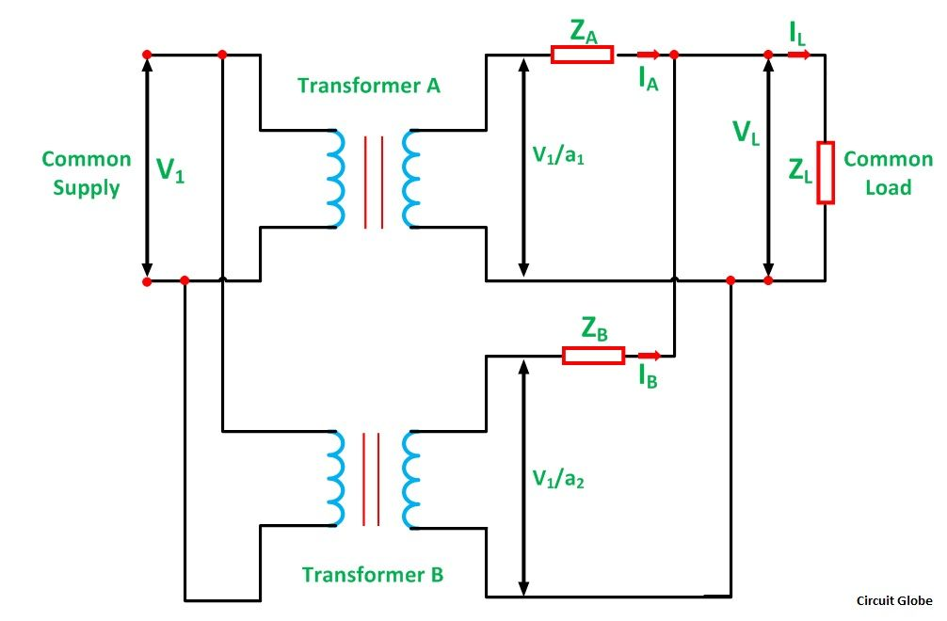
Let,
a₁ is the turn ratio of the transformer A
a₂ is the turn ratio of the transformer B
Z_{A} is the equivalent impedance of the transformer A referred to secondary
Z_{B} is the equivalent impedance of the transformer B referred to secondary
Z_{L} is the load impedance across the secondary
I_{A} is the current supplied to the load by the secondary of the transformer A
I_{B} is the current supplied to the load by the secondary of the transformer B
V_{L} is the secondary load voltage
I_{L} is the load current
Applying Kirchhoff’s Current Law$I_{A}+I_{B}=I_{L}\text{.}\text{.}\text{.}\text{.}\text{.}\text{.}\text{.}\text{.}\text{.}\text{.}\text{.}\text{.}\text{.}\text{.}\text{.}\text{.}\text{.}\text{.}\text{.}\text{.}\text{.}\text{.}\text{.}\text{.}\text{.}\text{.}\text{.}\text{.}\text{.}\text{.}\text{.}\text{.}\text{.}\text{.}\text{.}\text{.}\text{.}\text{.}\text{.}\text{.}\text{.}\text{.}\text{.}(1)$
By Kirchhoff’s Voltage Law
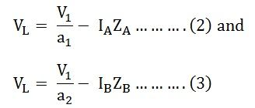
Now putting the value of I_{B} from the equation (1) in equation (3) we will get
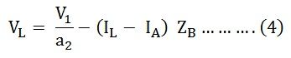
Solving equations (2) and (4) we will get
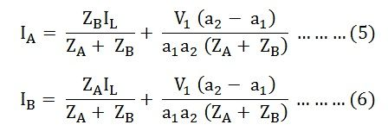
The current I_{A} and I_{B} has two components. The first component represents the transformers share of the load currents and the second component is a circulating current in the secondary windings of the single phase transformer.
The undesirable effects of the circulating currents are as follows
- They increase the copper loss.
- The circulating current overload the one transformer and reduce the permissible load kVA.
Equal Voltage Ratio
In order to eliminate circulating currents, the voltage ratios must be identical. That is a₁=a₂
Under this condition,
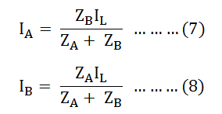
Equating equation (7) and (8) we will get
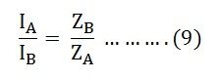
From the above equation (9), it is clear that the transformer currents are inversely proportional to the transformer impedance. Thus, for the efficient parallel operation of the two single phase transformers, the potential differences at full load across the transformer internal impedance should be equal.
This condition ensures that the load sharing between the two single phase transformer is according to the rating of each transformer. If the per unit equivalent impedance are not equal, then the transformer will not share the load in proportion to their kVA ratings. As a result, the overall rating of the transformer bank will be reduced.
Equation (9) can also be written as
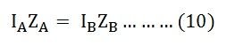
The current in the equations (7) and (8) is changed into volt-amperes by multiplying the two equations by the common load voltage V_{L}.
Therefore, we know that
The total load in volt-ampere (VA) is
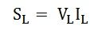
The volt-ampere of transformer A is
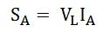
Similarly, the volt-ampere of transformer B is
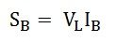
Hence, the various equations will be written as shown below
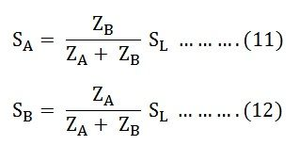
Equating the equation (11) and (12) we will get
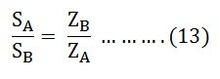
Equation (13) tells that the volt-ampere load on each single phase transformer is inversely proportional to its impedance.
Hence, to share the load in proportion to their ratings, the transformers should have the impedance which is inversely proportional to their ratings.

Parallel Operation of Transformers With Equal Voltage Ratios

Let us now consider the case of two transformers connected in parallel having equal voltage ratios. The two transformers are having no load secondary voltage same. i.e. E₁ = E₂ = E. These voltages are in phase with each other. This is possible if the magnetizing currents of the two transformers are not much different. With this case the primaries and Secondaries of the two transformers can be connected in parallel and no current will circulate under no load condition. This is represented in the Fig. 1.
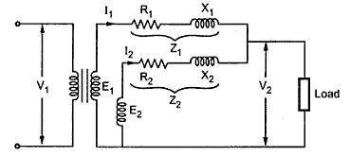
Fig.1
If we neglect magnetizing components, the two transformers are represented as shown in the Fig. 2.
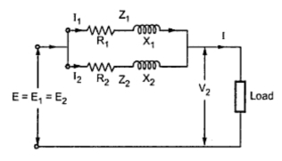
Fig 2
The phasor diagram under this case is shown in the Fig. 3. The two impedances Z₁ and Z₂ are in parallel. The values of Z₁ and Z₂ are with respect to secondary.
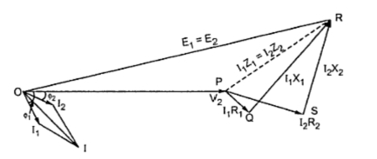
Fig 300
Z₁ and Z₂ are in parallel therefore the equivalent impedance is given by,
1/Z_{eq} = 1/Z₁ + 1/Z₂ Z_{eq} = Z₁ Z₂ /(Z₁ + Z₂ )
As seen from the phasor diagram
I₁ Z₁ = I₂ Z₂ = I Z_{eq}
I₁ = I Z_{eq}/ Z₁ = I Z₂ /( Z₁ + Z₂ )
I₂ = I Z_{eq}/ = I Z₁/( Z₁ + Z₂ )
Multiplying both terms of above equation by voltage V₂,
V₂ I₁ = = V₂ I Z₂ /( Z₁ + Z₂ )
V₂ I₂ = V₂ I Z₁/( Z₁ + Z₂)
But V₂ I x 10⁻³ is Q i.e. the combined load in KVA
From this KVA carried by each transformer is calculated as,
$Q_{1}=Q∗\frac{Z_{2}}{Z_{1}+Z_{2}}=Q∗\frac{1}{1+\frac{Z_{1}}{Z_{2}}}$ ; $Q_{2}=Q∗\frac{Z_{1}}{Z_{1}+Z_{2}}=Q∗\frac{1}{1+\frac{Z_{2}}{Z_{1}}}$
The above expressions are useful in determining the values of Q_{A} and Q_{B} in magnitude and in phase.
Key point: The equation contains impedance ratio hence ohmic values of resistances and reactances are not required.
The two transformers work at different power factor. One operates at high p.f. while the other at low p.f. If the impedances Z₁ and Z₂ are equal both in magnitude and quality i.e. (X₁/ R₁ = X₂/R₂ ), both transformers operate at the same p.f. which is the p.f. of the load.
This can be solved graphically also. First we have to draw currents I₁ and I₂ with angular difference of (Φ₁ - Φ₂) and magnitude inversely proportional to the respective impedances with some suitable scale. The phase sum of I₁ and I₂ gives total current I. From loading condition, the phase angle and magnitude of I can be obtained which can give the values of currents I₁ and I₂ can be determined.

- Parallel Operation of Transformers with Unequal Voltage Ratios

Now we will consider the case of two transformers working in parallel and having unequal voltage ratio. This is shown in the Fig. 1.
The voltage ratios of the two transformers are not equal. The parallel operation under this case is still possible. But as seen previously there would be a circulating current under no load condition.
Fig. 1
Let us consider voltage ratio of transformer 1 is slightly more than 2. So that induced e.m.f. E₁ is greater than E₂. Thus the resultant terminal voltage will be E₁ - E₂ which will cause a circulating current under no load condition.
I_{c} = (E₁ - E₂)/ (Z₁ + Z₂)
From the circuit diagram we have,
E₁ = V₂ + I₁ Z₁
E₂ = V₂ + I₂ Z₂
Also, I_{L} = I₁ + I₂
V₂ = I_{L} Z_{L} = ( I_{I} + I₂ ) Z_{L}
E₁ =(I₁ + I₂) Z_{L} + I_{I} Z₁ .........(a)
E₂ =(I₁ + I₂ ) Z_{L} + I₂ Z₂ .…....(b)
Subtracting equations (a) and (b) we have,
E₁ - E₂ = I₁ Z₁ - I₂ Z₂
I₁ = ((E₁ - E₂) + I₂ Z₂) /Z₁
Substuting this value in equation (b),$E_{2}=I_{2}Z_{2}+[\left\{\frac{(E_{1}−E_{2})+I_{2}Z_{2}}{Z_{1}}\right\}+I_{2}]Z_{L}$
... I₂ = (E₂ Z₁ - (E₁ - E₂)Z_{L}) / (Z₁ Z₂ + Z_{L} (Z₁ + Z₂))
Similarly, I₁ = (E₁ Z₂ + (E₁ - E₂)Z_{L})/ (Z₁ Z₂ + Z_{L} (Z₁ + Z₂))
Adding the above equations,
I₁ + I₂ = (E₁ Z₂ + E₂ Z₁) / (Z₁ Z₂ + Z_{L} (Z₁ + Z₂)) .............(c)
But I_{L} = I₁ + I₂
Load voltage, V₂ = I_{L} Z_{L}
Dividing both numerator and denominator of equation (c) by Z₁ Z₂,
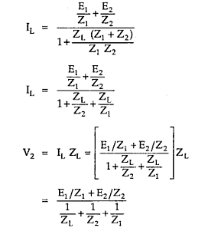
If impedances Z₁ and Z₂ are small in comparision with load impedance Z_{L} then product Z₁ Z₂ may be neglected so we get,
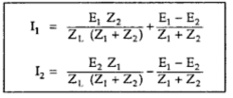
But we know that
(E₁ - E₂) / (Z₁ + Z₂) = I_{c}
Key Point : This circulating current I_{c} adds to I₁ but subtracts from I₂. Hence transformer 1 gets overloaded. The transformers will not share the load according to their ratings.
The phasor diagram is shown in the Fig. 2.
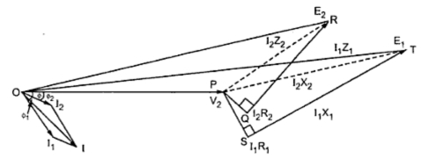
Fig. 2
The two transformers will operate at different power factor Φ₁ and Φ₂ are the power factor angles of these two transformers whereas Φ is the combined p.f. angle.
Here E_{A} and E_{B} have the same phase but there may be some phase difference between the two due to some difference of internal connection as for the connection in parallel of a Star/Star and a Star/Delta 3 phase transformers.
Key Point: While solving the problems on parallel operation of transformers it is convenient to work with numerical values of impedances instead of percentage values.

Auto Transformer
An Auto Transformer is a transformer with only one winding wound on a laminated core. An auto transformer is similar to a two winding transformer but differ in the way the primary and secondary winding are interrelated. A part of the winding is common to both primary and secondary sides. On load condition, a part of the load current is obtained directly from the supply and the remaining part is obtained by transformer action. An Auto transformer works as a voltage regulator.
In an ordinary transformer, the primary and the secondary windings are electrically insulated from each other but connected magnetically as shown in the figure below and in auto transformer the primary and the secondary windings are connected magnetically as well as electrically. In fact, a part of the single continuous winding is common to both primary and secondary.
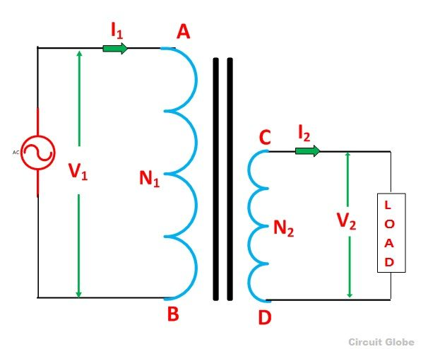
Figure A: Ordinary Two Winding Transformer
There are two types of auto transformer based on the construction. In one type of transformer, here is continuous winding with the taps brought out at convenient points determined by desired secondary voltage and in another type of auto transformer, there are two or more distinct coils which are electrically connected to form a continuous winding. The construction of Auto transformer is shown in the figure below.
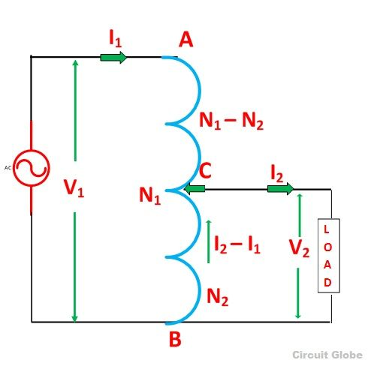
Figure B: Auto – Transformer
The primary winding AB from which a tapping at C is taken, such that CB acts as a secondary winding. The supply voltage is applied across AB, and the load is connected across CB. The tapping may be fixed or variable.When an AC voltage V₁ is applied across AB, an alternating flux is set up in the core, as a result, an emf E₁ is induced in the winding AB. A part of this induced emf is taken in the secondary circuit.
Let,
- V₁ – primary applied voltage
- V₂ – secondary voltage across the load
- I₁ – primary current
- I₂ – load current
- N₁ – number of turns between A and B
- N₂ – number of turns between C and B
Neglecting no load current, leakage reactance and losses,
V₁ = E₁ and V₂ = E₂
Therefore the transformation ratio K= $\frac{V_{2}}{V_{1}}=\frac{N_{2}}{N_{1}}=\frac{I_{1}}{I_{2}}$As the secondary ampere-turns are opposite to primary ampere turns, so the current I₂ is in phase opposition to I₁. The secondary voltage is less than the primary. Therefore current I₂ is more than the current I₁. Therefore, the resulting current flowing through section BC is (I₂ – I₁)The ampere-turns due to section BC = current turns
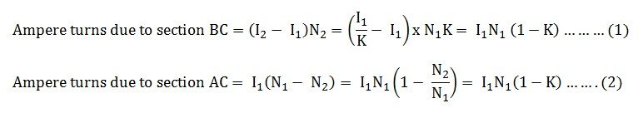Equation (1) and (2) shows that the ampere turns due to section BC and AC balance each other which is characteristic of the transformer action.

Saving of Copper in Auto Transformer as Compared to Ordinary Two Winding Transformer
The weight of the copper is proportional to the length and area of a cross section of the conductor.The length of the conductor is proportional to the number of turns, and the cross section is proportional to the product of current and number of turns.Now, from the above figure (B) shown of the auto transformer, the weight of copper required in an auto transformer isWa = weight of copper in section AC + weight of copper in section CBTherefore
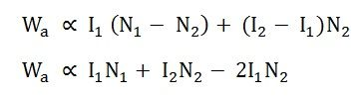
If the same duty is performed with an ordinary two winding transformer shown above in the figure (A)The total weight of the copper required in the ordinary transformerW₀ = weight of copper on its primary winding + weight of copper on its secondary windingTherefore,
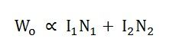
Now, the ratio of the weight of the copper in an auto transformer to the weight of copper in an ordinary transformer is given as
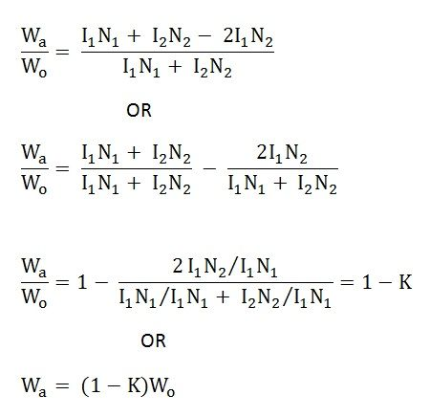
Saving of copper affected by using an auto transformer = weight of copper required in an ordinary transformer – weight of copper required in an auto transformer
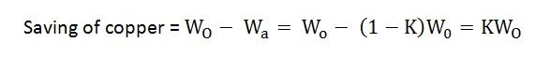
Therefore,saving of copper = K x weight of copper required for two windings of the transformerHence, saving in copper increases as the transformation ratio approaches to unity. Hence the auto transformer is used when the value of K is nearly equal to unity.

Advantages of Auto transformer
- Less costly
- Better regulation
- Low losses as compared to ordinary two winding transformer of the same rating.

Disadvantages of Auto transformer
There are various advantages of the auto transformer, but then also one major disadvantage, why auto transformer is not widely used, is that
- The secondary winding is not insulated from the primary winding.
If an auto transformer is used to supply low voltage from a high voltage and there is a break in the secondary winding, the full primary voltage comes across the secondary terminal which is dangerous to the operator and the equipment. So the auto transformer should not be used to for interconnecting high voltage and low voltage system.
- Used only in the limited places where a slight variation of the output voltage from input voltage is required.

Applications of Auto transformer
- It is used as a starter to give upto 50 to 60% of full voltage to the stator of a squirrel cage induction motor during starting.
- It is used to give a small boost to a distribution cable, to correct the voltage drop.
- It is also used as a voltage regulator
- Used in power transmission and distribution system and also in the audio system and railways.

